[E140] Fan

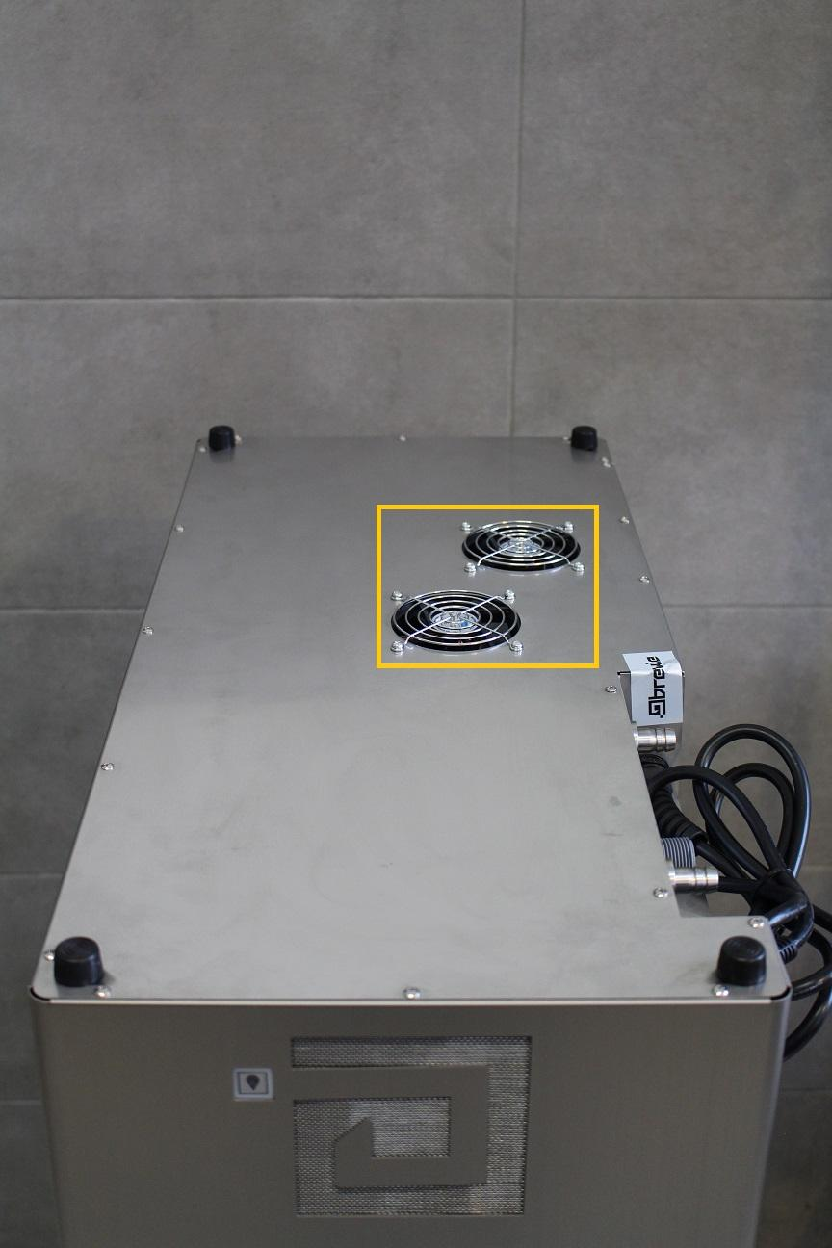

The fans are built-in the bottom plate. First unscrew all the screws holding the bottom plate and lift it up slowly. Disconnect the cables of the fans.

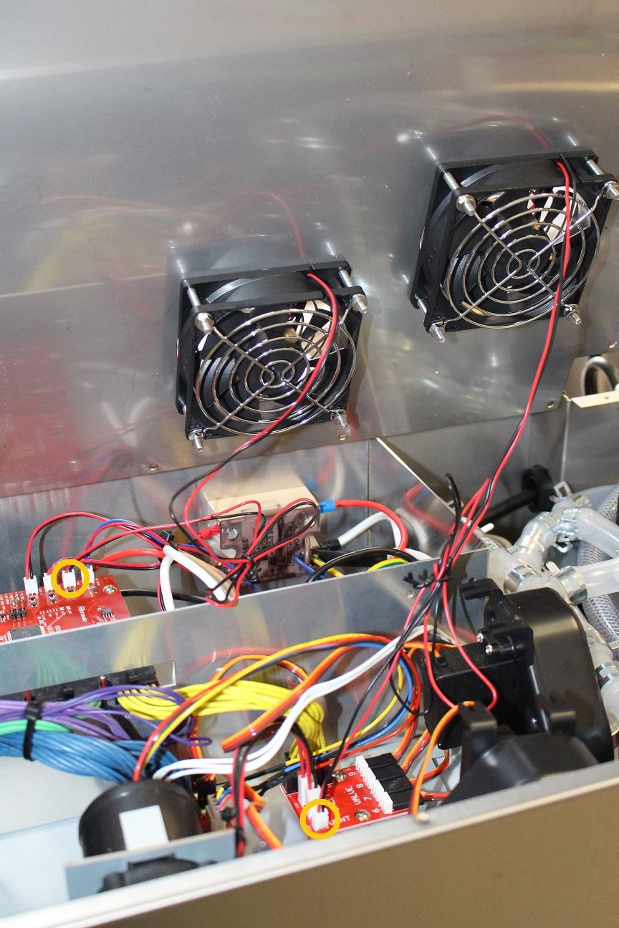

The fans can be removed by unscrewing the indicated screws and nuts.

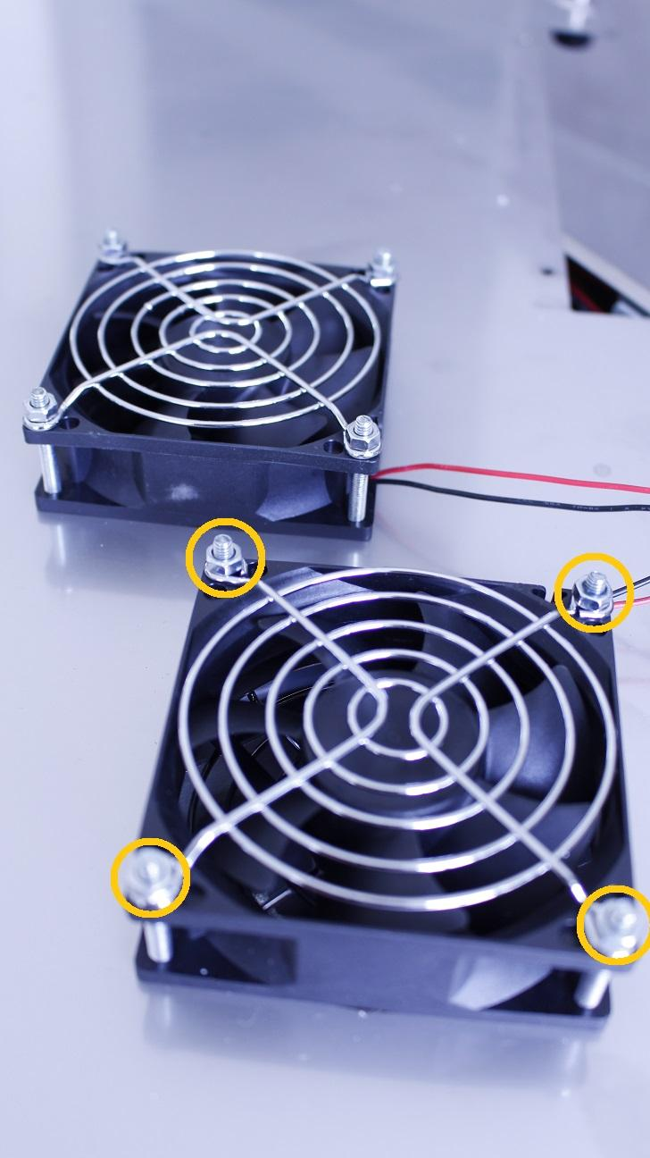

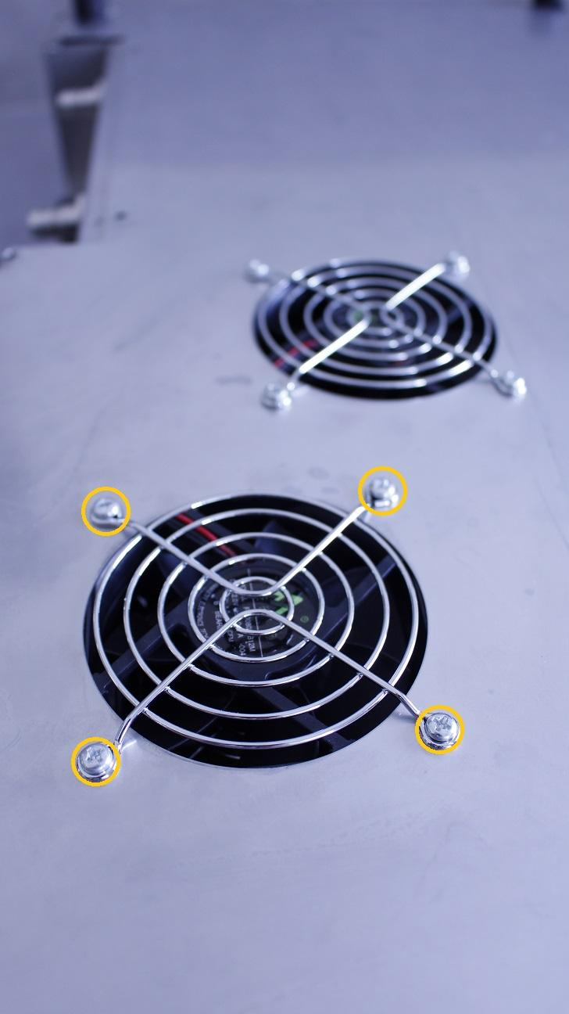

Reassemble consists of the same steps in reverse.

When reassembling, make sure, that the cables don’t interfere with the rotors.